Mr. Henry,

During this week I had a much more productive week. I was after a lot of research into the subject able to successfully publish my site, Jesse’s Hockey Shop onto the web. I found after much trial and error that your host does matter, and that my sturggles with Somee.com were all in vain because they didn’t have the resources I needed in order to host my site. Due to how my site is set up, I have two databases, and therefore two different connection strings in my Web.config, this lead to me needing a host that would allow me to have two databases and many of the free providers do not offer that.

When I turned my attention to Microsoft Azure everything came together. There was much more training and support material for using Microsoft Azure and I was able to use an Azure SDK built into Visual Studio in order to upload and publish my site with the click of one button, there was no need for a FTP or 3rd party system like Filezilla. I could upload it all via Visual Studio after I had the SDK.

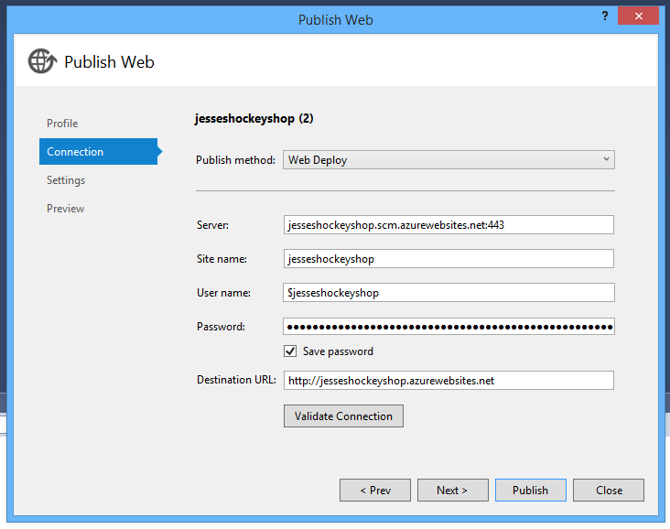

Please feel free to check out my site:

[http://http://jesseshockeyshop.azurewebsites.net/](http://http//jesseshockeyshop.azurewebsites.net/)

And provide feedback or let me know if you have suggestions on other items to change.

Overall I feel like this entire process has been very good. I started this project with the idea of just learning about automated testing, but it turned into learning about so much more. I’ve had to struggle with learning how to build a good structure to a web site in order to set up automated testing, and and even learned about the pain points of publishing your site. By going through these struggles I have learned a variety of different subjects that I didn’t plan on researching.

Now that I have my site published I will continue to work on my testing and begin to focus on my UI Testing. Since I can navigate to my sites URL I can now test loading times, and errors on my page.

-----------------------------------

As far as next steps go, have you heard back from a professor that I can give a presentation to? As the semester comes to an end I’d like to get an idea of when and who I’ll be presenting to.

Thanks for your time,

Jesse Fulcher